Phase 1: Recognition, Collection of Evidence, and Fixing of Vulnerabilities

Machine: The server is running on a machine that uses a weak password. Using a weak password comes with several serious disadvantages, especially in terms of security and privacy.

Unauthorized Access to the System
Malware or Ransomware Installation
Network Breach
Privilege Escalation
Data Theft or Loss
Service Disruption
Backdoors Installed
Lack of Audit Trail Integrity
Your System Used in Botnets
Legal and Compliance Issues

Username: debian
Password: 123456

*Note: High Risk

Identification of the Threat and Elimination of Vulnerabilities:

We change the password of the machine that hosts the server using strong password criteria.

Strong Password Criteria:
Length
Complexity
Unpredictability
No repetition or keyboard patterns
No dictionary words alone

We keep the system and all packages updated: sudo apt update && sudo apt upgrade

XAMPP: A file has been found in the Downloads folder.

Path of the File: /home/debian/Downloads/xampp-osx-8.0.28-0-installer.dmg

About XAMPP: XAMPP is a free, open-source software package that provides an easy way to set up a local web server environment on your computer. It’s primarily used for developing and testing web applications locally before deploying them to a live server.

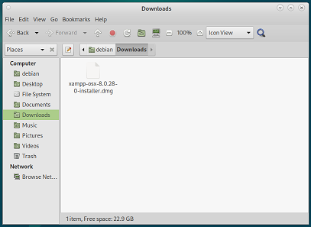
*Note: No Potential Risk

WordPress Account: A WordPress account has been found using weak credentials. Using weak credentials on a WordPress account (especially for admin users) poses significant risks.

Easy Target for Brute-Force Attacks
Unauthorized Admin Access
Website Defacement
Malware Injections
Service Disruption or Downtime
Stolen Customer Data
Search Engine Blacklisting
Reputation Damage
Repeated Breaches

Username: wordpress-user
Password: wordpressuser123456

Link: localhost/wp-login.php

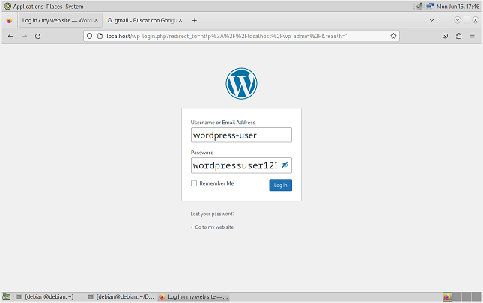
*Note: High Risk

Identification of the Threat and Elimination of Vulnerabilities:

We add a new user (e.g. Paul-5678) to WordPress and assign them the administrator role. Again, we use strong password criteria.

Strong Password Criteria:
Length
Complexity
Unpredictability
No repetition or keyboard patterns
No dictionary words alone

We delete the user wordpress-user and assign all their content to the new user we just created:
Paul-5678

( ! ) To delete the user wordpress-user, we must log in as Paul-5678.

Administration Email Verification: An administration email has been found. The administration email address is important because it is used for:

Receiving critical site notifications
Password recovery and security alerts
Plugin and theme update notices
Site health and error reports

Email: rosinnicuentas@gmail.com

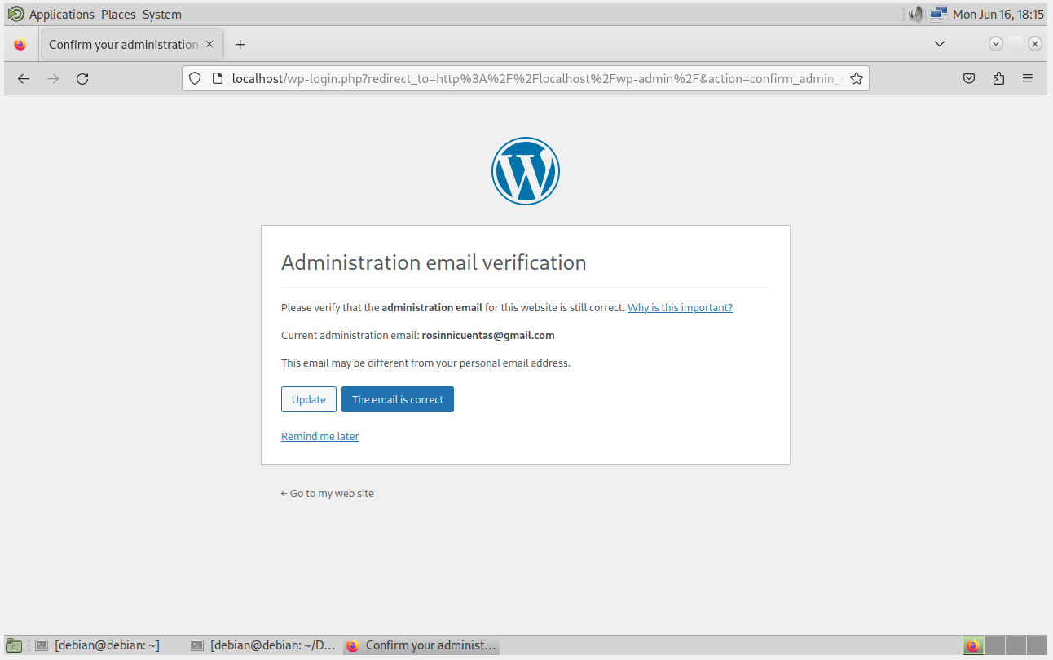
*Note: No Potential Risk

Following good configuration practices helps reduce security risks.
We log in as Paul-5678, go to Settings → General Settings, and change the Administration Email Address to match the email of the user Paul-5678.

( ! ) The new address will not become active until confirmed.

Gmail Account: A Gmail account has been found under the name: Astrid Mata

Gmail Account: mata.astrid.01@gmail.com

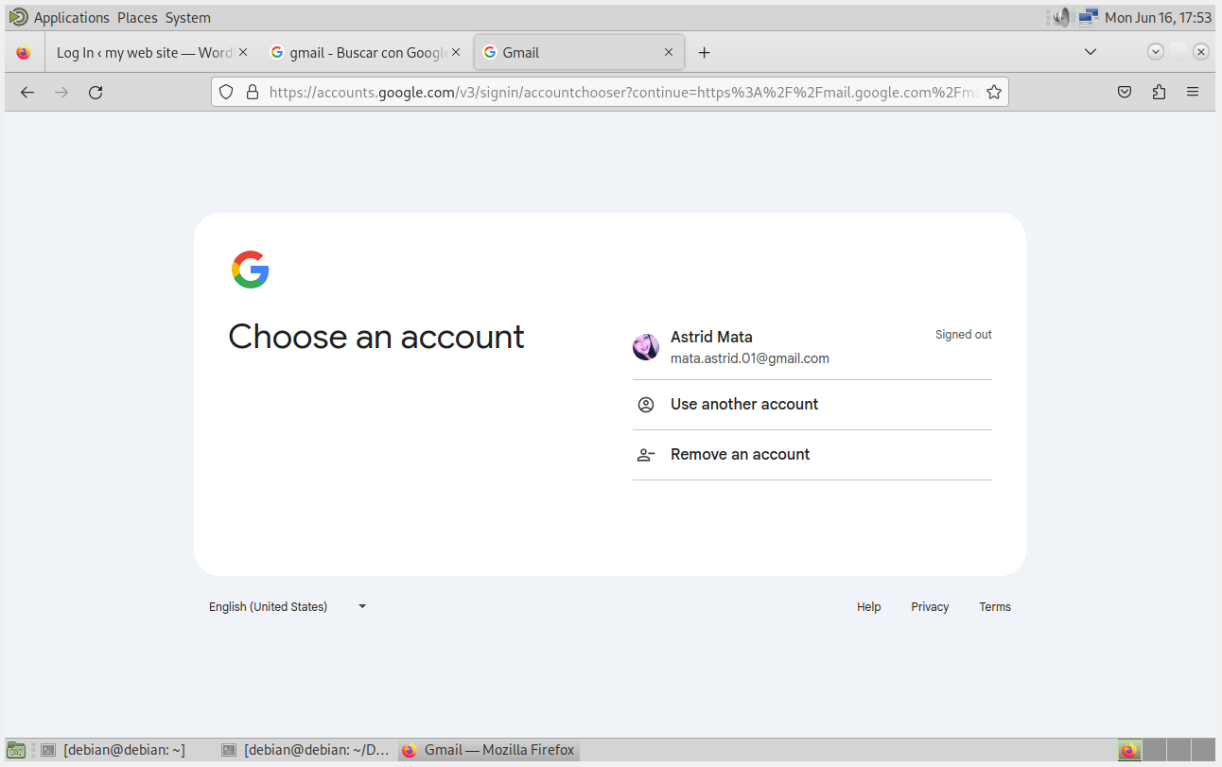
*Note: No Potential Risk

Mozilla Firefox: Browsing the Mozilla Firefox history can reveal a significant amount of information about a user's online activity.

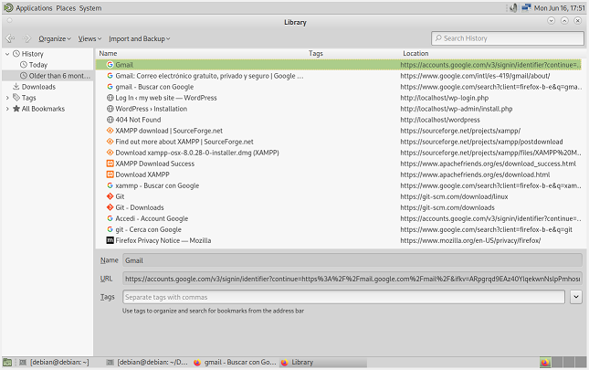
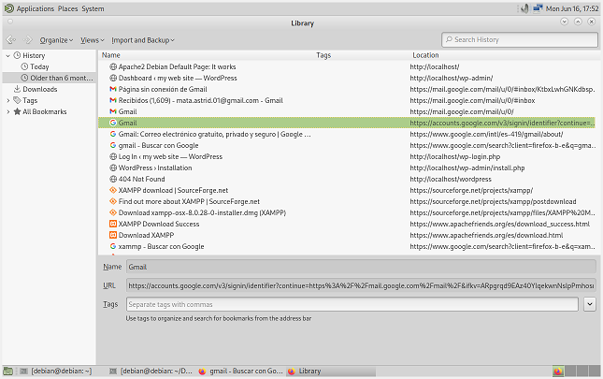
*Note: No Potential Risk

Mail Server: Having a weak mail server password on a WordPress site can open the door to serious security risks.

Unauthorized Access to Email Functions
Your Domain Could Be Blacklisted
Data Leakage
Reputation Damage
Potential for Full Website Compromise
Resource Drain

Login Name: login@example.com
Password: password

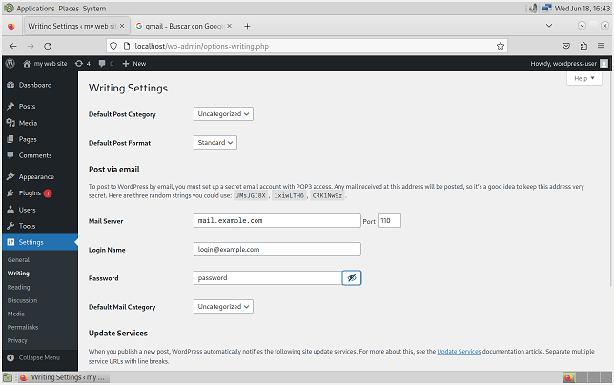
*Note: High Risk

Identification of the Threat and Elimination of Vulnerabilities:

We log in as Paul-5678, go to Settings → Writing Settings, and update the email password using strong password criteria.

Strong Password Criteria:
Length
Complexity
Unpredictability
No repetition or keyboard patterns
No dictionary words alone

Site Health Status

Plugins:
Outdated plugins are tempting targets for attackers.

Themes:
Outdated themes are also tempting targets for attackers.

HTTPS:
Not using HTTPS (SSL/TLS) on a WordPress site is a serious security and trust issue.

Leaving outdated plugins and themes on a WordPress site can create serious security, performance, and maintenance issues.

Security Vulnerabilities
Expanded Attack Surface
Can Be Reactivated by Accident or Maliciously
Slower Maintenance and Troubleshooting
Compatibility Risks
Legal and Compliance Issues
Waste of Server Resources

The main cons and risks of not using HTTPS (SSL/TLS) on a WordPress site:

Data Can Be Intercepted (Man-in-the-Middle Attacks)
User Trust Drops Immediately
Negative Impact on SEO (Search Ranking)
Modern Features Break Without HTTPS
Plugin/API Integrations May Refuse Connections
Security Tools May Flag or Limit You

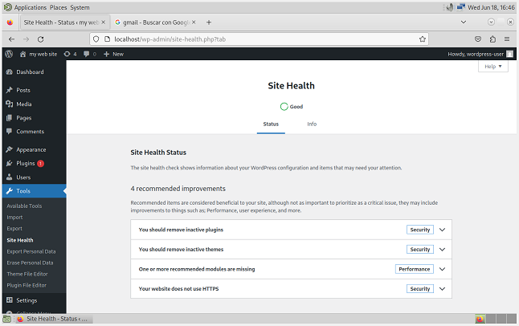
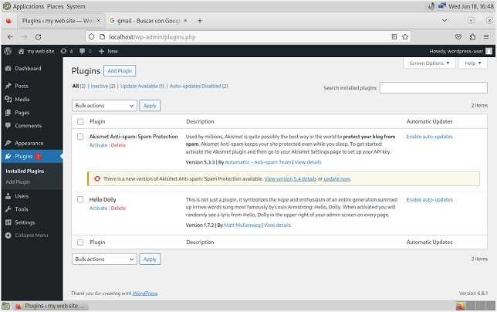

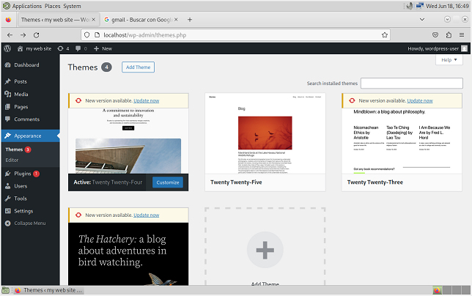
*Note: High Risk

Identification of the Threat and Elimination of Vulnerabilities:

We log in as Paul-5678 and go to Plugins. We activate, update and enable auto-updates for the plugins we want to use.

( ! ) We must delete, not just deactivate, plugins we don't use, as they may remain outdated and become a tempting target for attackers.

We log in as Paul-5678 and go to Appearance → Themes. We update the active theme.

( ! ) It is recommended to delete inactive themes to enhance the site's security.

About HTTPS:

You cannot use Let's Encrypt or a public SSL certificate on:
localhost
A private IP address like 127.0.0.1 or 192.168.x.x

Because:
Let’s Encrypt and other Certificate Authorities (CAs) only issue certificates for valid domain names.
localhost and IPs are not verifiable as domain ownership.

We can use HTTPS on localhost or our IP address with a self-signed certificate.

( ! ) The use of a self-signed SSL certificate is out of the scope of the exercise.

Verification of MySQL Configuration

To connect to a MySQL (or MariaDB) server on a Debian Linux system from the command line, we can use the mysql command: mysql -u root -p

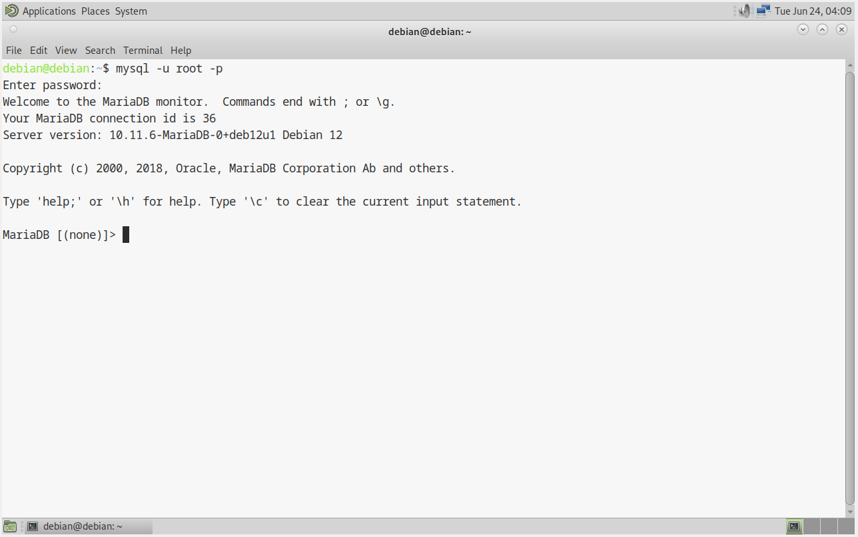
Check Users and Authentication

-- View all MySQL users and their hosts
SELECT user, host, authentication_string FROM mysql.user;

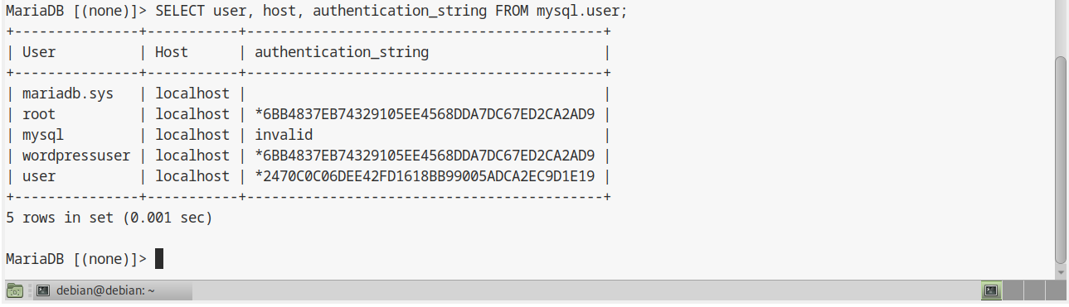

-- Check for users with empty passwords
SELECT user, host FROM mysql.user WHERE authentication_string = '';

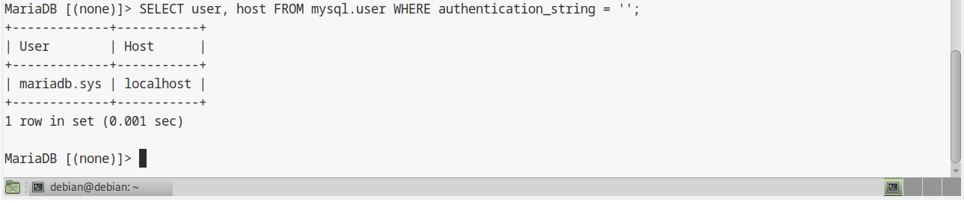
Review User Privileges

-- Show privileges for all users
SELECT user, host FROM mysql.user;

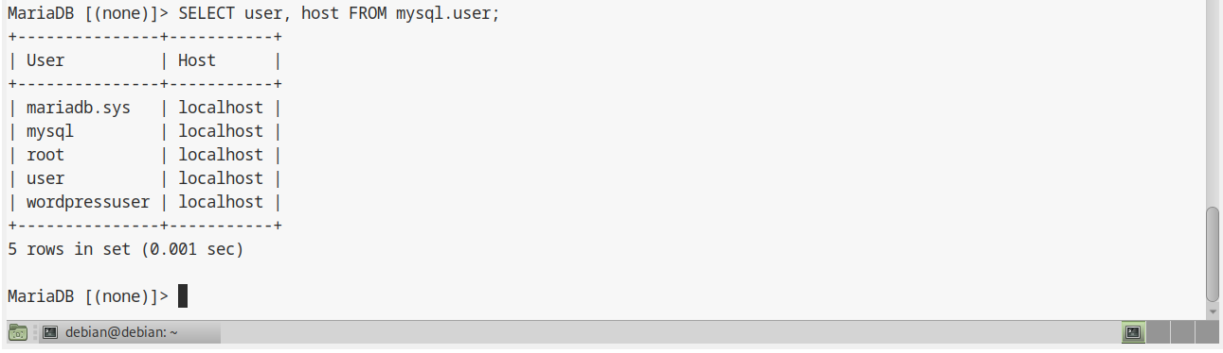
-- Check for users with excessive privileges
SELECT user, host FROM mysql.user WHERE Super_priv = 'Y' OR Grant_priv = 'Y';

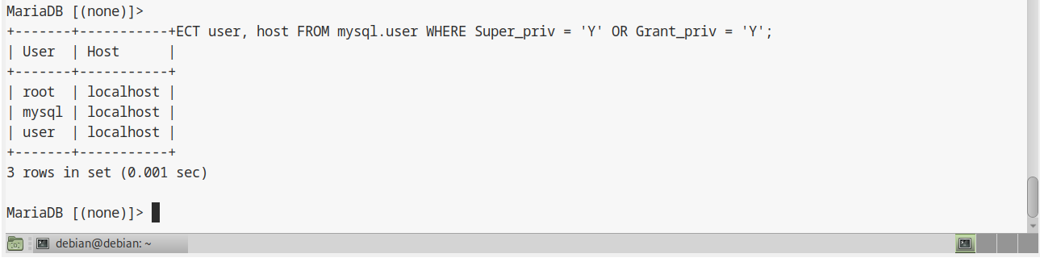

How to Fix the mariadb.sys User

-- Set a password for the user
ALTER USER 'mariadb.sys'@'localhost' IDENTIFIED BY 'v9#TgZ1@cLp8!XeM';

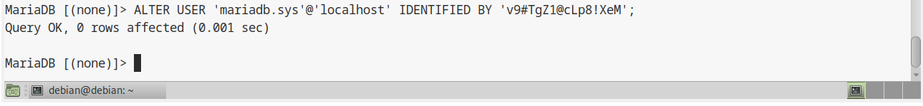
Verification After Fix

-- Verify the user now has a password
SELECT user, host, authentication_string FROM mysql.user WHERE user = 'mariadb.sys';

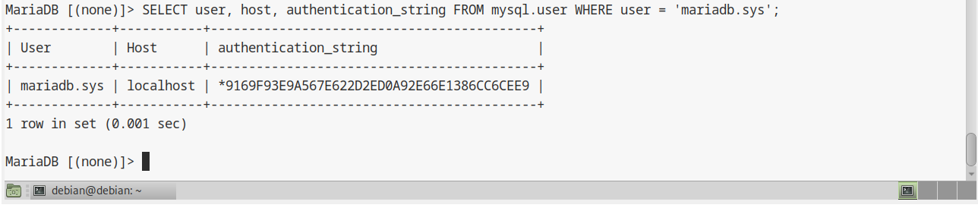
-- Check that no users have empty passwords anymore
SELECT user, host FROM mysql.user WHERE authentication_string = '';

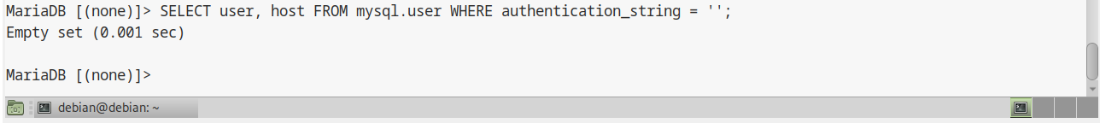
Check Complete User Information

-- More readable format for key security fields
SELECT user, host, authentication_string, Super_priv, Grant_priv, File_priv, Process_priv, Shutdown_priv, Create_user_priv, Reload_priv FROM mysql.user WHERE user IN ('user');

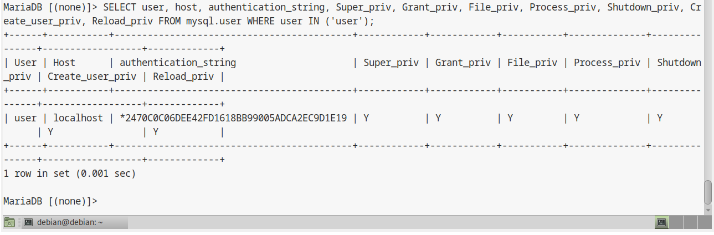

Check Privileges for a User

-- Show all privileges for a user
SHOW GRANTS FOR 'user'@'localhost';

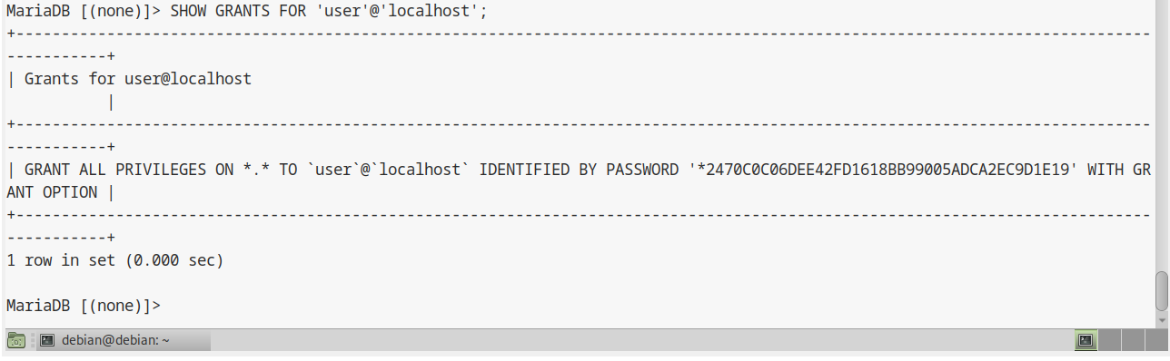
Investigate Suspicious Activity

-- Check for users with dangerous file privileges
SELECT user, host FROM mysql.user WHERE File_priv = 'Y' AND user IN ('user');

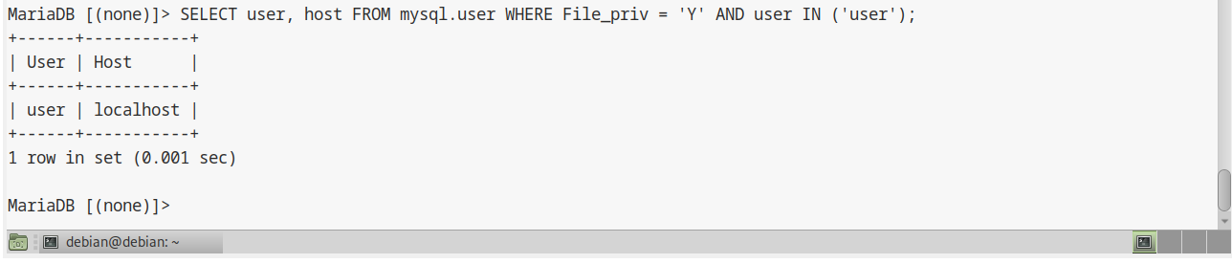
-- Check for users who can create other users
SELECT user, host FROM mysql.user WHERE Create_user_priv = 'Y' AND user IN ('user');

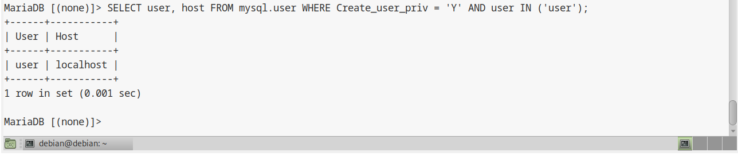

Immediate Actions if Malicious User Suspected

-- Lock suspicious accounts immediately
ALTER USER 'user'@'localhost' ACCOUNT LOCK;

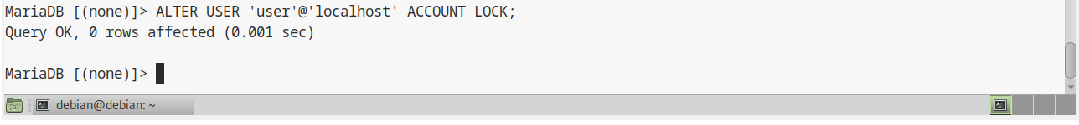
-- Remove dangerous privileges
REVOKE ALL PRIVILEGES ON *.* FROM 'user'@'localhost';

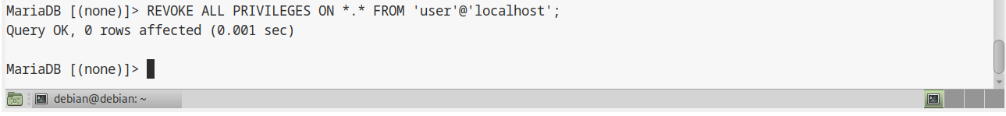
-- Drop the user if confirmed malicious
DROP USER 'user'@'localhost';

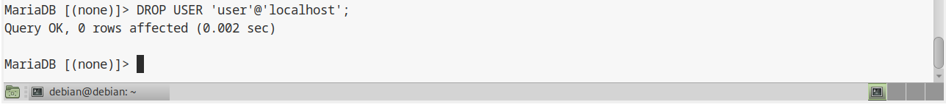
Check Users and Authentication

-- View all MySQL users and their hosts
SELECT user, host, authentication_string FROM mysql.user;

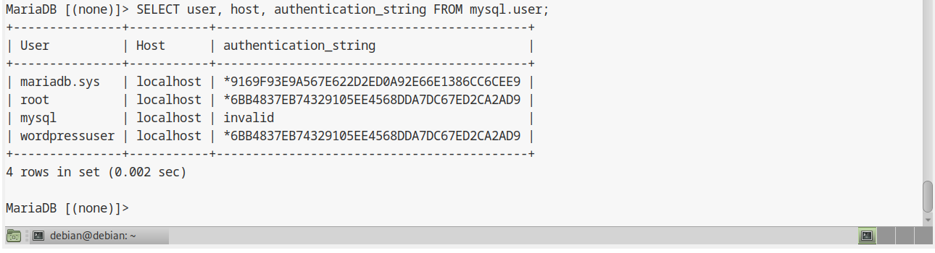
How to Fix the mysql User

-- Set a new password for the mysql user
ALTER USER 'mysql'@'localhost' IDENTIFIED BY 'Y9$fP#1vR@xL!2eN';

Check Users and Authentication

-- View all MySQL users and their hosts
SELECT user, host, authentication_string FROM mysql.user;

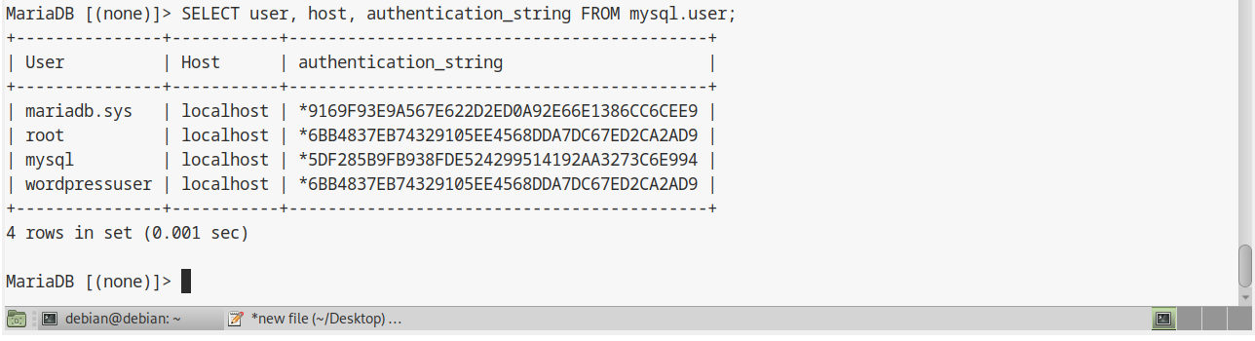
How to Fix the wordpressuser User
( ! ) The user wordpressuser was found to be using a weak password, so we are going to fix that.

-- Set a new password for the wordpressuser user
ALTER USER 'wordpressuser'@'localhost' IDENTIFIED BY 'T7@uKz!1r#DqF6%m';

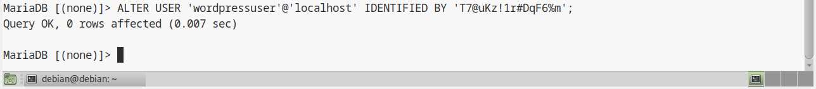
How to Fix the root User
( ! ) The user root was found to be using a weak password, so we are going to fix that.

-- Set a new password for the root user
ALTER USER 'root'@'localhost' IDENTIFIED BY 'N7$wRt1&Jx5!Vo3^';

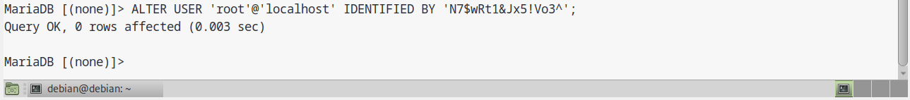
How to Fix the user User
( ! ) The user user was found to be using a weak password, so we are going to fix that.

-- Set a new password for the user user
ALTER USER 'user'@'localhost' IDENTIFIED BY 'xC7^m!Lq8#Z2@oRe';

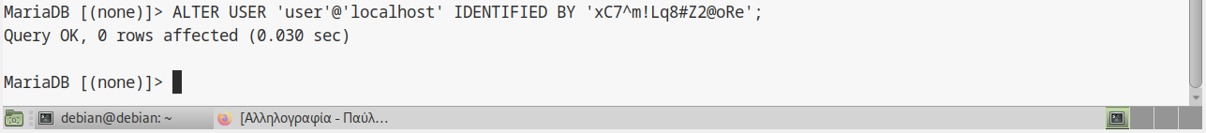

( ! ) The mariadb.sys account in MariaDB is a special system user used internally by the database.

What is mariadb.sys?

It's created by default during MariaDB installation.
It is used internally for certain operations and performance schema tasks.
It does not need to log in, nor should it ever be used manually.
It's not intended for general use.

( ! ) Locking it prevents interactive login attempts, improving security.

( ! ) MariaDB can still use it internally as needed — locking the login doesn't break anything.

We lock the mariadb.sys account as a best practice for secure configuration.

-- Lock the account
ALTER USER 'mariadb.sys'@'localhost' ACCOUNT LOCK;

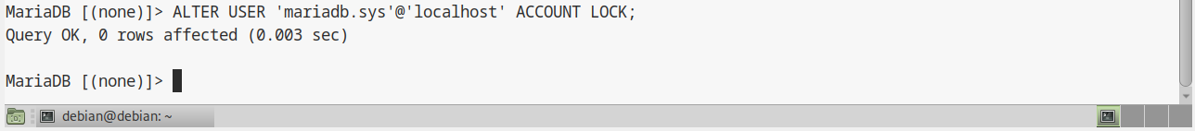
*Note: High Risk

Journal: In Linux, the journal typically refers to the systemd journal, which is a component of the systemd system and service manager. It is responsible for collecting and storing log messages from the kernel, services, and various system components.

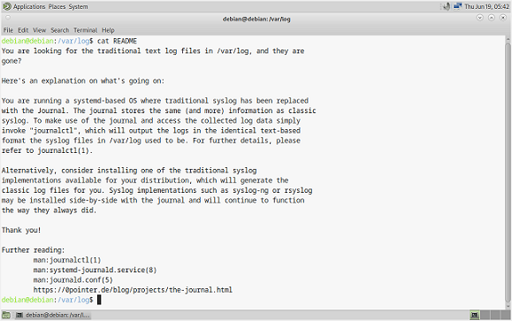

Path of the File: /var/log/journal

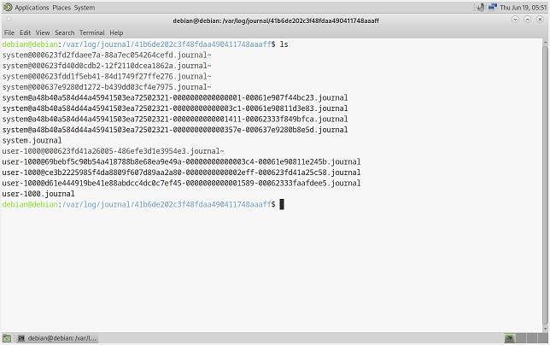
We can check the machine's | PORT | STATE | SERVICE | and | VERSION | by using Nmap and Kali Linux.

→ Scan Services and Versions:
Command used: sudo nmap -sV 10.0.2.17

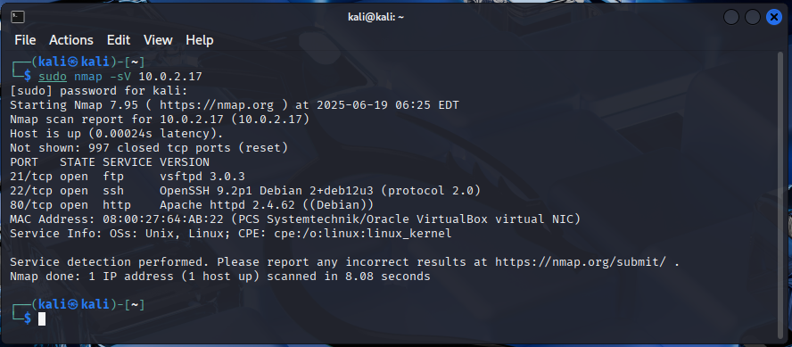

We scan PORT 80 on the host 10.0.2.17 for known vulnerabilities using a set of pre-defined NSE (Nmap Scripting Engine) scripts from the vuln category.

Command used: nmap -p 80 --script vuln 10.0.2.17

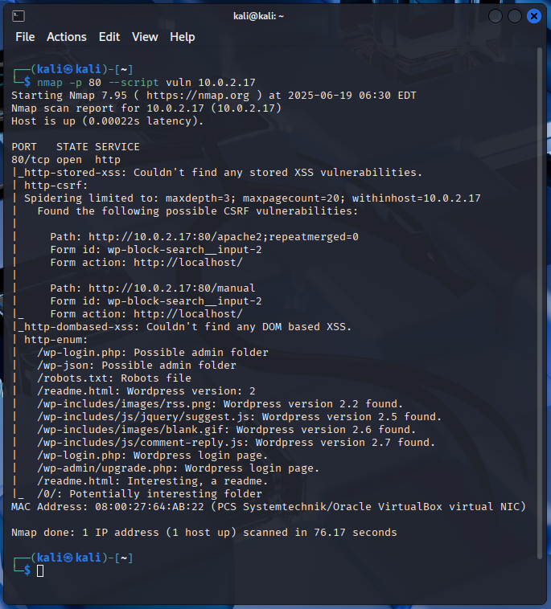
( ! ) Vulnerabilities have been found on PORT 80.

We are using the journal to filter Services / Units.

Logs from SSH Service:
Command used: sudo journalctl -u ssh

( ! ) System logs are owned by the root user, and reading them requires elevated permissions.

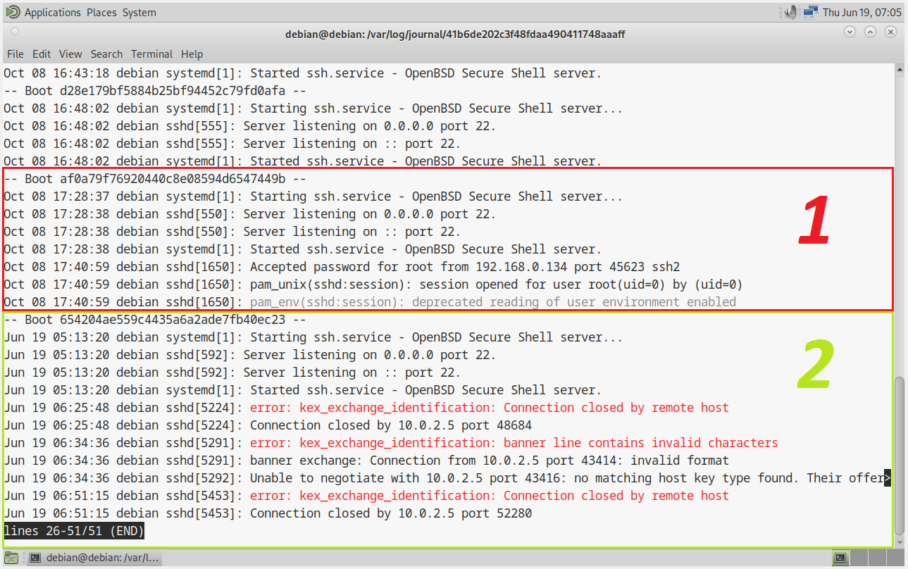
Number 1: A user successfully logged in as root to this machine over SSH, from the IP address 192.168.0.134, using a password.

→ Details:
"accepted password": A login attempt using a password was successful.

"for root": The login was made to the user account root, which is the system administrator (superuser) account.

"from 192.168.0.134": The login originated from the IP address 192.168.0.134, which is a private (local network) IP.

"port 45623": The remote connection originated from port 45623 on the client's machine. (This is typically assigned dynamically.)

"ssh2": The connection used the SSH protocol version 2, which is standard and secure.

Number 2: We will ignore Number 2 as the IP address 10.0.2.5 belongs to the Kali Linux we are using for the investigation.

*Note: High Risk

Identification of the Threat and Elimination of Vulnerabilities:

We checked the machine's | PORT | STATE | SERVICE | and | VERSION | by using Nmap and Kali Linux.

By using the journal, we checked the logs from the SSH Service and found that a user successfully logged in as root to this machine over SSH from the IP address 192.168.0.134 using a password.

Securing SSH is a key step in system hardening to prevent unauthorized access.
STEPS:
Disable Root SSH Login
This command opens the SSH server configuration file (sshd_config) in the nano editor with root permissions: sudo nano /etc/ssh/sshd_config

We find and modify these lines:
PermitRootLogin no
PasswordAuthentication no # Optional: disable password auth entirely
PubkeyAuthentication yes # Enable key-based auth

We add the user named debian to the sudo group, giving that user administrative privileges on a Debian-based system: sudo usermod -aG sudo debian

Set Up SSH Key Authentication
ssh-keygen -t rsa -b 4096

( ! ) What is the passphrase?
It's a password that you choose — it's not something predefined.
It is used to encrypt your private SSH key, adding a layer of security.

( ! ) We will use a strong passphrase, as it makes brute-force or dictionary attacks extremely difficult.

We copy the public key to our server: ssh-copy-id debian@10.0.2.17

Restart SSH Service: sudo systemctl restart ssh

Once the key is copied, we can SSH into the machine like this: ssh debian@10.0.2.17

Additional Security Measures
sudo nano /etc/ssh/sshd_config
Port 2222 # Change default port
AllowUsers debian # Only allow specific users
MaxAuthTries 3 # Limit login attempts
ClientAliveInterval 300 # Timeout idle connections

( ! ) Remember to remove the hash (#) for the commands to take effect.

Port 21 (FTP):
High security risk - FTP transmits credentials in plain text
Unnecessary for WordPress management
Can be replaced with SFTP (uses SSH port 22)

Stop and disable FTP service:
sudo systemctl stop vsftpd
sudo systemctl disable vsftpd

Remove FTP server if not needed:
sudo apt remove vsftpd

Use SFTP instead for file transfers: sftp debian@10.0.2.17

Additional Security Steps:
# Configure UFW firewall
sudo ufw enable
sudo ufw allow 80/tcp
sudo ufw allow 443/tcp
# Block the IP that logged in as root
sudo ufw deny from 192.168.0.134
# Block with logging to track future attempts
sudo ufw deny from 192.168.0.134 comment "Blocked root SSH login"

We are fixing vulnerabilities that have been found on port 80.
WP-CLI: WP-CLI stands for WordPress Command Line Interface. It’s a command-line tool for managing WordPress websites — ideal for developers, sysadmins, and power users who want to work faster and automate tasks without needing to use the WordPress admin dashboard.

Step 1: Download WP-CLI
curl -O https://raw.githubusercontent.com/wp-cli/builds/gh-pages/phar/wp-cli.phar

Step 2: Make it executable
chmod +x wp-cli.phar

Step 3: Move it to your PATH
sudo mv wp-cli.phar /usr/local/bin/wp

Step 4: Test it
wp --info

We navigate to /var/www/html and run the following commands to fix vulnerabilities:

Fix CSRF Vulnerabilities:
# Update WordPress core
wp core update
wp core update-db

# Update all plugins
wp plugin update --all

# Update all themes
wp theme update --all

Secure Exposed Admin Areas:
File: .htaccess
Path of the File: /var/www/html
List hidden files (including .htaccess): Command used: ls -la

Command used: sudo nano .htaccess

We add to .htaccess file:
# Block access to wp-admin for non-logged users
<Files "wp-login.php">
Require ip 10.0.2.17
# Or use password protection
</Files>

# Block direct access to sensitive files
<Files ~ "^(readme\.html|wp-config\.php|robots\.txt)$">
Require all denied
</Files>

Remove/Secure Information Disclosure:
Command used: sudo nano wp-config.php

# Add to wp-config.php or functions.php
remove_action('wp_head', 'wp_generator');

# Remove readme files
rm /var/www/html/readme.html
rm /var/www/html/wp-admin/upgrade.php # if not needed

Update WordPress configuration (wp-config.php):
Command used: sudo nano wp-config.php

# Add security headers
define('DISALLOW_FILE_EDIT', true);
define('WP_DEBUG', false);
define('FORCE_SSL_ADMIN', true);

# Change security keys
# Generate new keys at https://api.wordpress.org/secret-key/1.1/salt/

Server-Level Security:
# Set correct permissions
sudo find /var/www/html/ -type d -exec chmod 755 {} \;
sudo find /var/www/html/ -type f -exec chmod 644 {} \;
sudo chmod 600 wp-config.php

Block direct PHP execution in uploads:
Command used: sudo nano .htaccess

# Add to uploads/.htaccess
<Files "*.php">
Require all denied
</Files>

Verify Fixes: Command used: nmap -p 80 --script vuln 10.0.2.17

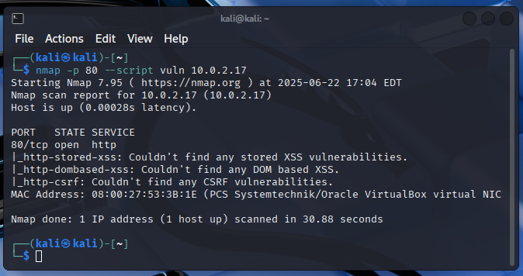

Rootkit Hunter: Is a Unix-based tool used to detect rootkits, backdoors, and possible local exploits on a system

Command used: sudo rkhunter --check

Rootkit Hunter findings:

[ WARNING ] /usr/bin/lwp-request

[ WARNING ] Checking for suspicious (large) shared memory segments

[ WARNING ] Checking if SSH root access is allowed

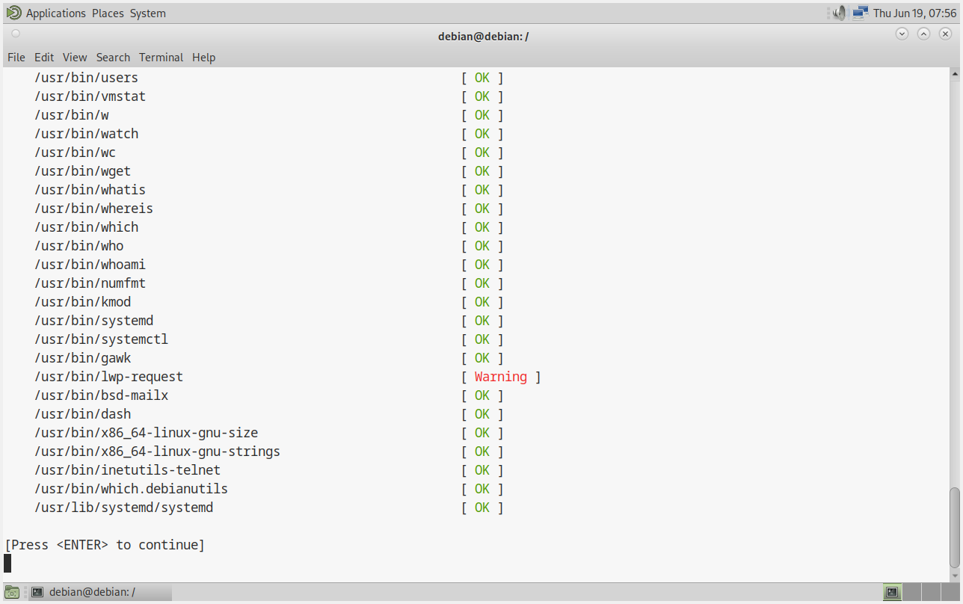

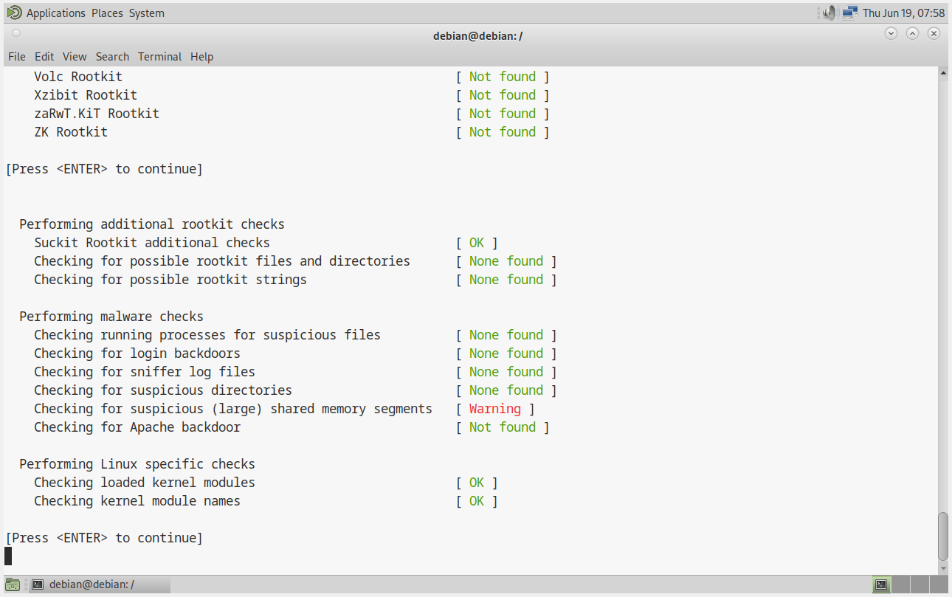
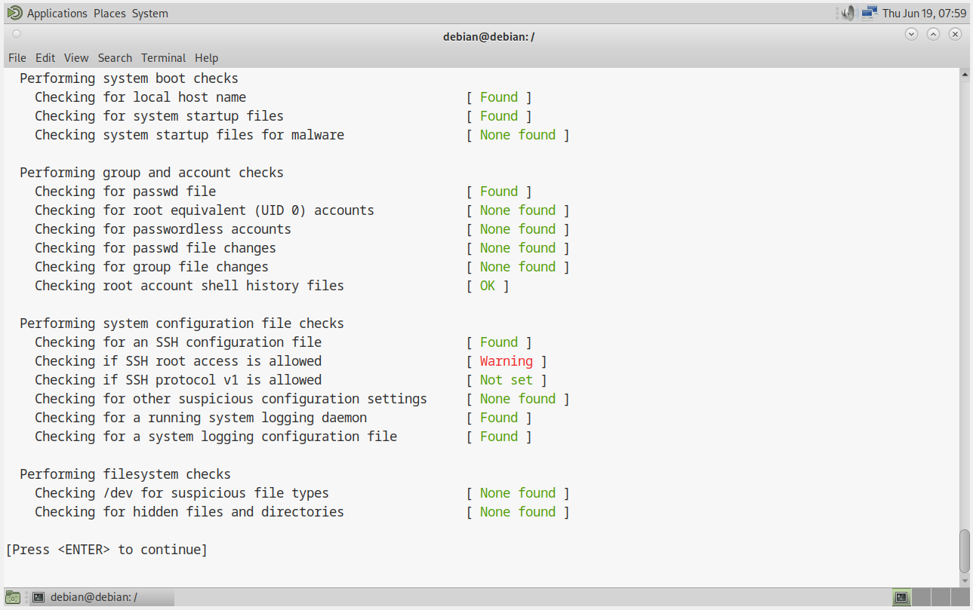
*Note: High Risk

Identification of the Threat and Elimination of Vulnerabilities:

Rootkit Hunter:

Rootkit Hunter findings:

[ WARNING ] /usr/bin/lwp-request

( ! ) /usr/bin/lwp-request is not suspicious by default — it's a legitimate system utility, and rkhunter is just being cautious.

[ WARNING ] Checking for suspicious (large) shared memory segments

# Check current shared memory
ipcs -m

# Check processes using large memory
ps aux --sort=-%mem | head -20

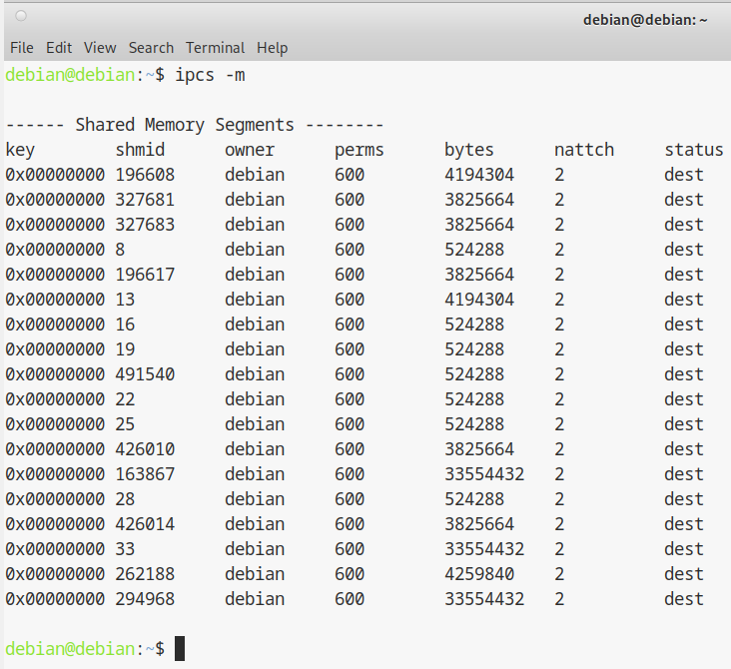

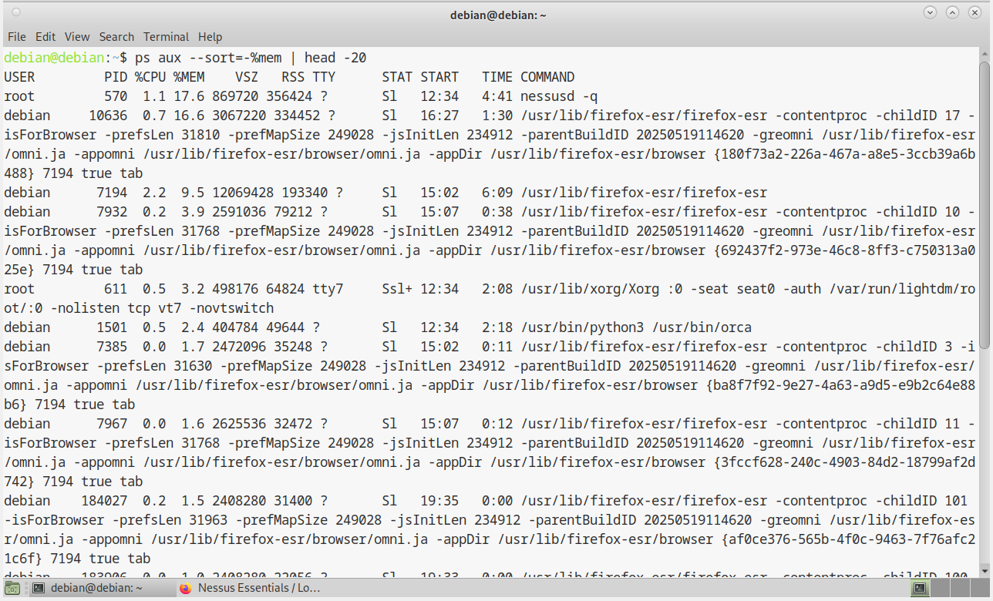
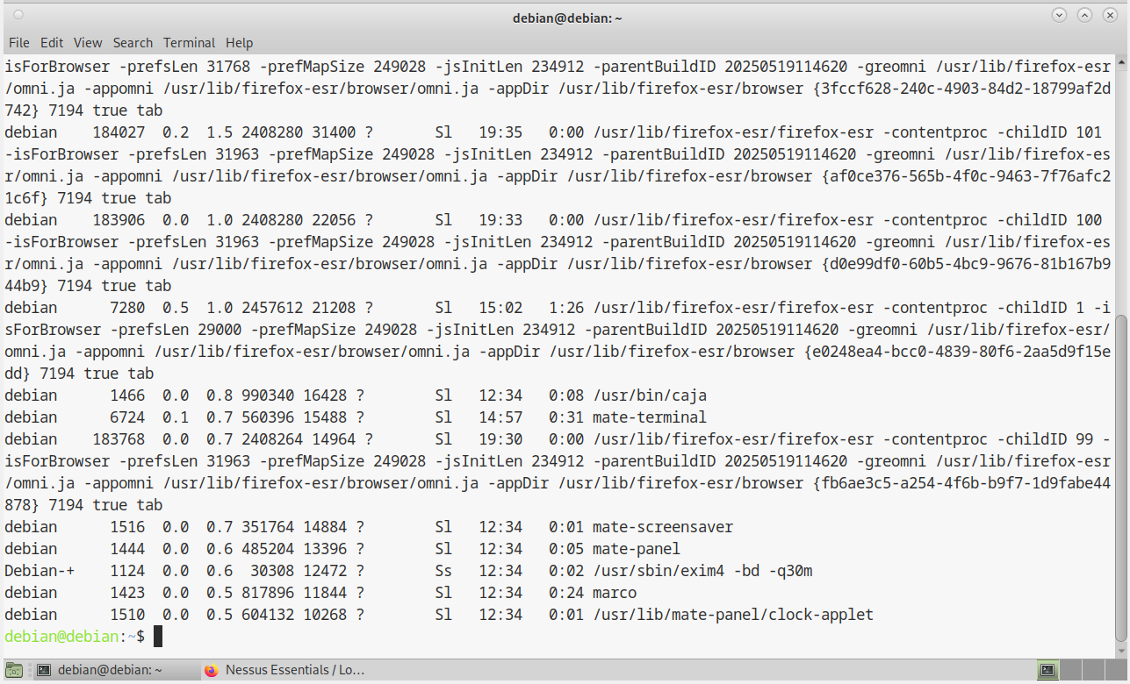

This is NOT Suspicious Because:

Owner is legitimate - All owned by your user account debian.
Proper permissions - 600 means only you can access them.
Normal sizes - Desktop applications typically use 1-10MB shared memory.
Cleanup status - dest means segments are properly marked for cleanup.
No root-owned segments - No system compromise indicators.

[ WARNING ] Checking if SSH root access is allowed

( ! ) The vulnerability has already been fixed. Please check the Journal section.

Hashcat: Hashcat is a password recovery tool used to crack password hashes using various attack methods. It’s widely used by cybersecurity professionals, penetration testers, and ethical hackers, as well as by attackers for malicious purposes.

( ! ) Hashcat will be used to illustrate how quickly an insecure password can be broken.

STEP 1: We extract password hashes from MariaDB and move them to Kali Linux for analysis.

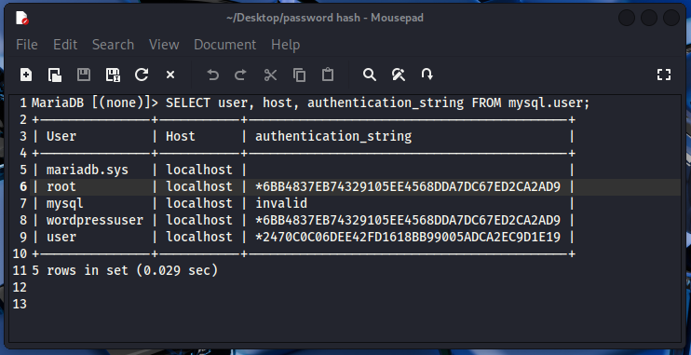
STEP 2: We use the tool hash-identifier to identify the hashing algorithm likely used to generate the hash.

Command used: hash-identifier 6BB4837EB74329105EE4568DDA7DC67ED2CA2AD9

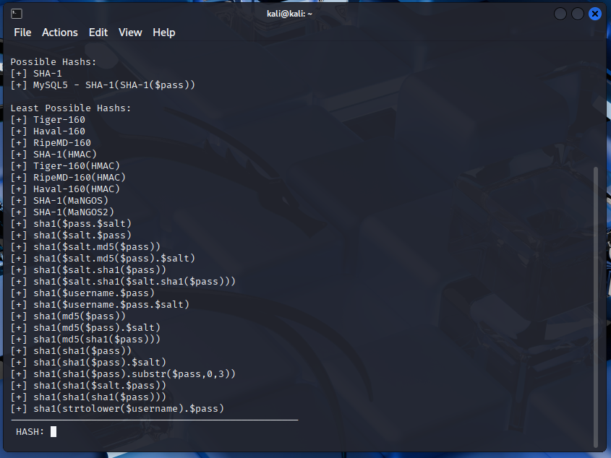
( ! ) The hash-identifier output shows two categories of hash types.

[+] SHA-1
[+] MySQL5 - SHA-1(SHA-1($pass))

STEP 3: We use the tool hashcat to search for MySQL5-specific hash modes in Hashcat's help output.

Command used: hashcat -h | grep MySQL5

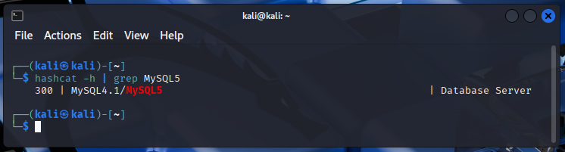

STEP 4: We are using the hashcat tool to crack a MySQL5 password hash with a dictionary attack.

Command used: hashcat -a 0 -m 300 6BB4837EB74329105EE4568DDA7DC67ED2CA2AD9 Desktop/mypasswords.txt

Command Breakdown:

The hash cracking tool: hashcat

Attack mode 0 (Dictionary / Wordlist attack): -a 0

Hash mode 300 (MySQL4.1 / MySQL5 format): -m 300

The target hash to crack (root user's hash): 6BB4837EB74329105EE4568DDA7DC67ED2CA2AD9

The wordlist file containing potential passwords: Desktop/mypasswords.txt

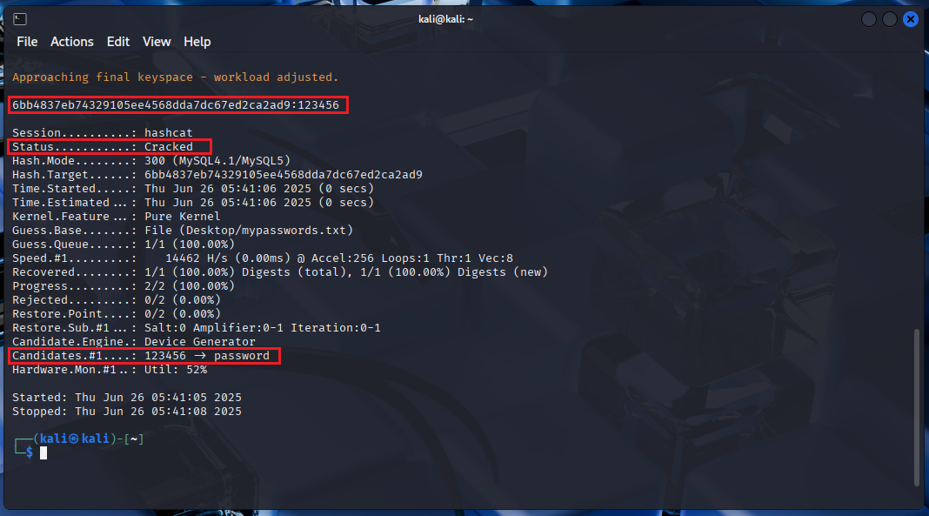
( ! ) The password for the user root has been cracked!

Username: root
Password: 123456

( ! ) We also see that the users root and wordpressuser share the same hash, meaning that the user wordpressuser also has the same password: 123456

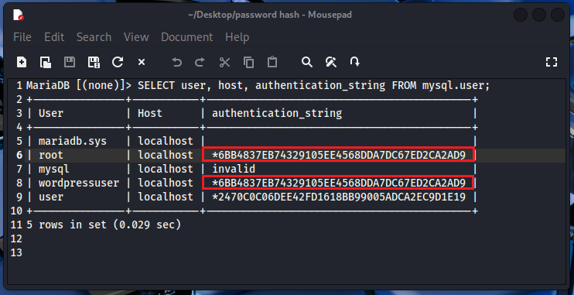
Username: wordpressuser
Password: 123456

( ! ) We should use strong password criteria to protect our accounts and data from unauthorized access.

Strong Password Criteria:
Length
Complexity
Unpredictability
No repetition or keyboard patterns
No dictionary words alone

Having strong password criteria helps protect user accounts from brute-force and dictionary attacks, ensures data security, and reduces the risk of unauthorized access.

Security Recommendations to Prevent Future Attacks:
A set of security best practices and recommendations to help prevent future attacks related to weak credentials, outdated software, and insecure configurations, especially on a WordPress-based server.

Use Strong, Unique Passwords
Use a password manager to generate and store long, complex passwords.
Secure SSH Access
Disable root login.
Use SSH key authentication.
Change default SSH port.
Limit SSH access to specific users.
Keep WordPress Core, Plugins, and Themes Updated
Use WP-CLI or set up automatic updates.
Remove unused plugins and themes — unused code can become a hidden entry point.
Enforce HTTPS (SSL/TLS)
Use Let’s Encrypt for free SSL certificates.
Redirect all HTTP to HTTPS in .htaccess or your web server config.
Secure WordPress Credentials
Set strong passwords for all WordPress users.
Limit admin accounts — give users the minimum role they need.
Secure Mail Server Accounts
Use strong SMTP/IMAP/POP passwords.
Limit Privileged Access
Only allow trusted users access to:
SSH
WordPress admin
Mail server configuration
Regular Backups
UpdraftPlus is a popular WordPress backup and restoration plugin. It helps WordPress site owners back up, restore, and migrate their websites easily.
Install a Firewall
Protect against brute-force attacks.
System Hardening
Disable unnecessary services.
Keep the system and all packages updated.
Monitor logs.

